

**Assignment**

*Develop a JavaScript-based mobile shopping cart feature that uses ES6 arrow functions, array methods*

*(map, filter, reduce), and object manipulation to manage items in a shopping cart.*

**Submitted by**

Roshan Ali Khattak

Sp22-bse-014

**Introduction**

The objective of this assignment is to implement a JavaScript-based shopping cart using ES6 features, including arrow functions, array methods like map, filter, and reduce, and object manipulation. The goal is to allow users to add, remove, update items, calculate total costs, and apply a discount to the shopping cart.

**Code Explanation**

Shopping Cart Array

The cart array is used to store product objects, each containing properties like productId, productName, quantity, and price.

**Add iteam to cart**

This function takes product details as arguments, creates a product object, and adds it to the cart array using the push method.

**RemoveItemFromCart**

It finds the index of the product based on productId, then removes the product from the cart using the splice method. If the product is not found, an error message is displayed.

**UpdateItemQuantity**

This function updates the quantity of a specific product using the map method. If the productId matches, it returns a new product object with the updated quantity, ensuring immutability.

**CalculateTotalCost**

The reduce method calculates the total cost by multiplying the quantity and price of each product and summing them up.

**DisplayCartSummary**

This function uses the map method to iterate over the cart and display each product's name, quantity, and total price.

**FilterOutZeroQuantityItems**

This function removes any products from the cart that have a quantity of zero using the filter method.

**ApplyDiscount**

If a valid discount code (DISCOUNT10) is provided, the function calculates the discount and applies it to the total cost.

This code efficiently handles basic shopping cart functionalities using modern ES6 features.

**Screenshots**

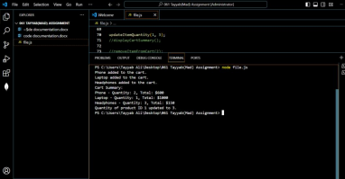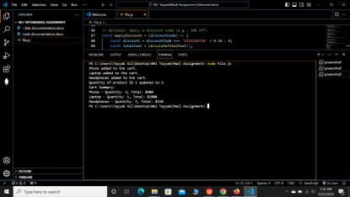

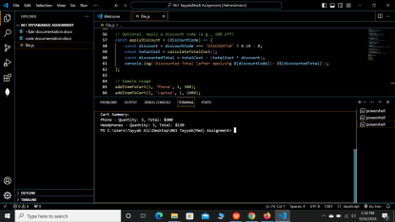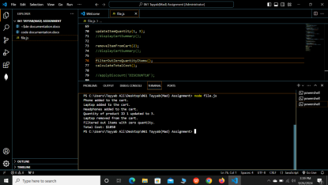

**Conclusion**

Through this assignment, I gained deeper insights into ES6 features, particularly arrow functions, array manipulation methods (map, filter, reduce), and object immutability. It reinforced my understanding of how modern JavaScript techniques can streamline code and make it more readable and efficient.